- WAP to read sales of 5 salesmen for 12 months and print total sales

// WAP to read sales of 5 salesmen for 12 months and print total sales
#include<iostream.h>
#include<conio.h>
#include<stdio.h>
main()
{
clrscr();
int a[5][12],c,sum=0,totsum,tot[5];
char yorn;
cout<<endl<<"The maximum number of salesmen is 5 ";
for(int r=0;r<5;r++)
{
cout<<"\n\nEnter 12 month sales of salesman "<<r+1<<"\n\n\n";
for(c=0,sum=0;c<12;c++)
{
cout<<"\tEnter sales ";
cin>>a[r][c];
sum+=a[r][c];
}
tot[r]=sum;
cout<<"The total sales of salesman "<<r+1<<" is "<<sum;
totsum+=sum;
if(r==4)
break;
cout<<"\n Do you wish to continue to next salesman(Y/N) ";
cin>>yorn;
if(yorn=='y')
clrscr();
else
{
break;
}
}
cout<<"\n\n The total sum of all salesmen is "<<totsum;
sum:
cout<<"\n\n Do you wish to see the sum of a salesman?(Y/N) ";
cin>>yorn;
if(yorn=='y')
{
clrscr();
cout<<"\nEnter salesman number ";
cin>>c;
cout<<"\n\n The sales of this salesman is "<<tot[c-1];
}
else
goto end;

goto sum;

end:
cout<<"\nThank You!";
getch();
}

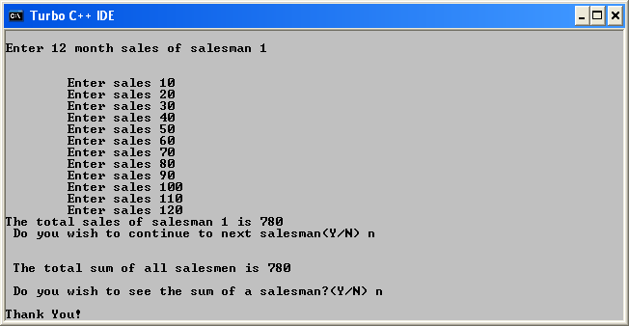

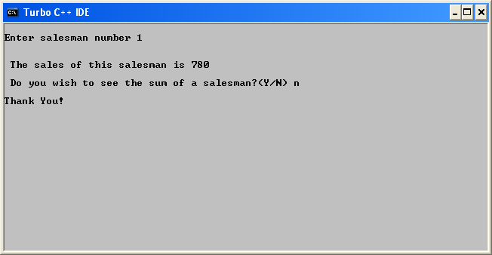

- To calculate grades of students

//To calculate grades of students
#include<iostream.h>
#include<conio.h>
#include<stdio.h>
main()
{
clrscr();
int mark[4][3],avg[4];
for(int r=0;r<4;r++)
{
cout<<"\nEnter marks of student "<<r+1<<endl;
for(int c=0,sum=0;c<3;c++)
{
cout<<"\nEnter marks of test "<<c+1<<" out of 100 ";
cin>>mark[r][c];
sum+=mark[r][c];
}
avg[r]=sum/3;
if(avg[r]>=90)
cout<<"\nStudent "<<r+1<<" has got A grade ";
else if(avg[r]<90 && avg[r]>=80)
cout<<"\nStudent "<<r+1<<" has got B grade ";
else
cout<<"\nStudent "<<r+1<<" has got C grade ";
cout<<"\n____________________________\n";
}
getch();
}

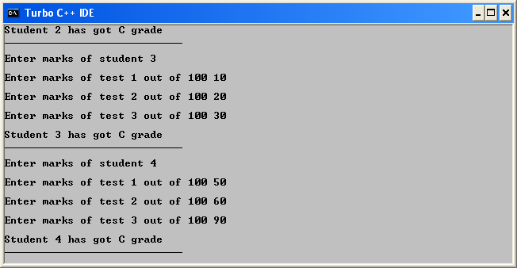
- WAP to check if two matrix are equal

//WAP to check if two matrix are equal
#include<iostream.h>
#include<conio.h>
#include<stdio.h>
main()
{
clrscr();
int a[4][3],b[4][3],r,c;

//Fetching the Matrix

for(r=0;r<4;r++)
{
cout<<"\nEnter the values in first matrice for row "<<r+1<<endl;
for(c=0;c<3;c++)
{
cout<<"Enter value for column "<<c+1<<" ";
cin>>a[r][c];
}
cout<<"------------------------------------";
}
clrscr();
for(r=0;r<4;r++)
{
cout<<"\nEnter the values in second matrix for row "<<r+1<<endl;
for(c=0;c<3;c++)
{
cout<<"Enter value for column "<<c+1<<" ";
cin>>b[r][c];
}
cout<<"------------------------------------";
}
clrscr();

//Printing first Matrix

cout<<"\n Matrix 1 entered is "<<endl<<endl;
for(int j=0;j<4;j++)
{
for(int k=0;k<1;k++)
cout<<a[j][k]<<'\t'<<a[j][1]<<'\t'<<a[j][2]<<endl;
}

//Printing second matrix

cout<<"\n Matrix 2 entered is "<<endl<<endl;
for(int l=0;l<4;l++)
{
for(int m=0;m<1;m++)
cout<<b[l][0]<<'\t'<<b[l][1]<<'\t'<<b[l][2]<<endl;
}

//Checking Equality

for(r=0,l=0;r<4;r++)
{
for(c=0;c<3;c++)
{
if(a[r][c]!=b[r][c])
l++;
}
}
if(l==0)
cout<<"\n\n The matrix are equal";
else
cout<<"\n\n The matrix are unequal";

getch();
}

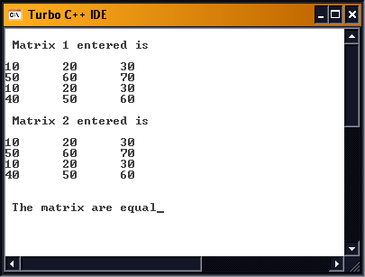

4) WAP to add two matrix

//WAP to add two matrix

#include<iostream.h>
#include<conio.h>
#include<stdio.h>
main()
{
clrscr();
int a[4][3],b[4][3],r,c,add[4][3];

//Fetching the Matrix

for(r=0;r<4;r++)
{
cout<<"\nEnter the values in first matrice for row "<<r+1<<endl;
for(c=0;c<3;c++)
{
cout<<"Enter value for column "<<c+1<<" ";
cin>>a[r][c];
}
cout<<"------------------------------------";
}
clrscr();
for(r=0;r<4;r++)
{
cout<<"\nEnter the values in second matrix for row "<<r+1<<endl;
for(c=0;c<3;c++)
{
cout<<"Enter value for column "<<c+1<<" ";
cin>>b[r][c];
}
cout<<"------------------------------------";
}
clrscr();

//Printing first Matrix

cout<<"\n Matrix 1 entered is "<<endl<<endl;
for(int j=0;j<4;j++)
{
for(int k=0;k<1;k++)
cout<<a[j][k]<<'\t'<<a[j][1]<<'\t'<<a[j][2]<<endl;
}

//Printing second matrix

cout<<"\n Matrix 2 entered is "<<endl<<endl;
for(int l=0;l<4;l++)
{
for(int m=0;m<1;m++)
cout<<b[l][0]<<'\t'<<b[l][1]<<'\t'<<b[l][2]<<endl;
}

//ADDING THE MATRIX

for(r=0,l=0;r<4;r++)
{
for(c=0;c<3;c++)
{
add[r][c]=a[r][c]+b[r][c];
}
}

cout<<"\n The sum of the two is "<<endl<<endl;
for(l=0;l<4;l++)
{
for(int m=0;m<1;m++)
cout<<add[l][0]<<'\t'<<add[l][1]<<'\t'<<add[l][2]<<endl;
}

getch();
}

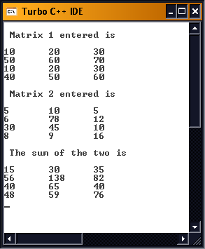

- WAP to subtract two matrices

//WAP to subtract two matrices
#include<iostream.h>
#include<conio.h>
#include<stdio.h>
main()
{
clrscr();
int a[4][3],b[4][3],r,c,sub[4][3];

//FETCHING the Matrix

for(r=0;r<4;r++)
{
cout<<"\nEnter the values in first matrice for row "<<r+1<<endl;
for(c=0;c<3;c++)
{
cout<<"Enter value for column "<<c+1<<" ";
cin>>a[r][c];
}
cout<<"------------------------------------";
}
clrscr();
for(r=0;r<4;r++)
{
cout<<"\nEnter the values in second matrix for row "<<r+1<<endl;
for(c=0;c<3;c++)
{
cout<<"Enter value for column "<<c+1<<" ";
cin>>b[r][c];
}
cout<<"------------------------------------";
}
clrscr();

//Printing first Matrix

cout<<"\n Matrix 1 entered is "<<endl<<endl;
for(int j=0;j<4;j++)
{
for(int k=0;k<1;k++)
cout<<a[j][k]<<'\t'<<a[j][1]<<'\t'<<a[j][2]<<endl;
}

//Printing second matrix

cout<<"\n Matrix 2 entered is "<<endl<<endl;
for(int l=0;l<4;l++)
{
for(int m=0;m<1;m++)
cout<<b[l][0]<<'\t'<<b[l][1]<<'\t'<<b[l][2]<<endl;
}

//SUBTRACTING THE MATRIX

for(r=0,l=0;r<4;r++)
{
for(c=0;c<3;c++)
{
sub[r][c]=a[r][c]-b[r][c];
}
}

//PRINTING RESULT

cout<<"\n The subtraction of the two is "<<endl<<endl;
for(l=0;l<4;l++)
{
for(int m=0;m<1;m++)
cout<<sub[l][0]<<'\t'<<sub[l][1]<<'\t'<<sub[l][2]<<endl;
}

getch();
}

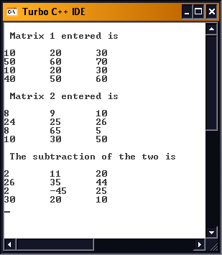

- WAP to find row sum of a matrix

//WAP to find row sum of a matrix
#include<iostream.h>
#include<conio.h>
#include<stdio.h>
main()
{
clrscr();
int a[4][3],r,c,sum;

//FETCHING the Matrix

for(r=0;r<4;r++)
{
cout<<"\nEnter the values in matrice for row "<<r+1<<endl;
for(c=0;c<3;c++)
{
cout<<"Enter value for column "<<c+1<<" ";
cin>>a[r][c];
}
cout<<"------------------------------------";
}
clrscr();

//Printing Matrix

cout<<"\n Matrix 1 entered is "<<endl<<endl;
for(r=0;r<4;r++)
{
for(int c=0;c<1;c++)
cout<<a[r][0]<<'\t'<<a[r][1]<<'\t'<<a[r][2]<<endl;
}
for(r=0,sum=0;r<4;r++)
{
for(c=0,sum=0;c<3;c++)
sum+=a[r][c];
cout<<"\n Sum of row "<<r+1<<" is "<<sum;
}
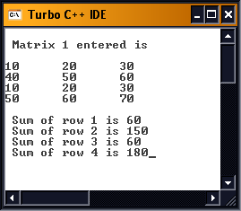
getch();
}

- WAP to transpose a matrix

//WAP to transpose a matrix
#include<iostream.h>
#include<conio.h>
#include<stdio.h>
main()
{
clrscr();
int a[3][3],b[3][3],r,c,sum;

//FETCHING the Matrix

for(r=0;r<3;r++)
{
cout<<"\nEnter the values in matrice for row "<<r+1<<endl;
for(c=0;c<3;c++)
{
cout<<"Enter value for column "<<c+1<<" ";
cin>>a[r][c];
}
cout<<"------------------------------------";
}
clrscr();

//Printing Matrix

cout<<"\n Matrix 1 entered is "<<endl<<endl;
for(r=0;r<3;r++)
{
for(int c=0;c<1;c++)
cout<<a[r][0]<<'\t'<<a[r][1]<<'\t'<<a[r][2]<<endl;
}
//SWAPPING VALUES

for(r=0,sum=0;r<3;r++)
{
for(c=0,sum=0;c<3;c++)
b[r][c]=a[c][r];
}
for(r=0;r<3;r++)
{
for(c=0;c<3;c++)
a[r][c]=b[r][c];
}

//Printing The Transpose

cout<<"\n The transpose is "<<endl<<endl;
for(r=0;r<3;r++)
{
for(int c=0;c<1;c++)
cout<<a[r][0]<<'\t'<<a[r][1]<<'\t'<<a[r][2]<<endl;
}

getch();
}
